Bridgepoint Parts Catalog

Section XXXIII: Hydro-Force Injection Sprayer Parts Page 1

NA0820

Valve – Metal Spray Gun with Viton Packing
5GPM - 1000PSI

Used on AS08M, AS22A & AS89

Repair Parts:
Shut Off Disk: NA0822
Stem: PS7482-1-BR
V-Packing: PF1425S-1-VI
Repair Kit: (Stem & V-Packing) NA0821

NA0820A Valve – Plastic Spray Gun

5GPM - 1850PSI

Used on AS08, AS08R, AS23, AS18, AS71, AS73XL & AS74 Sprayers. Also used on the AS58 & AS60 Pressure washing guns.
Repair Parts:
Valve: NA0845
Rebuild Kit: NA0842

Jet Body: NA0802
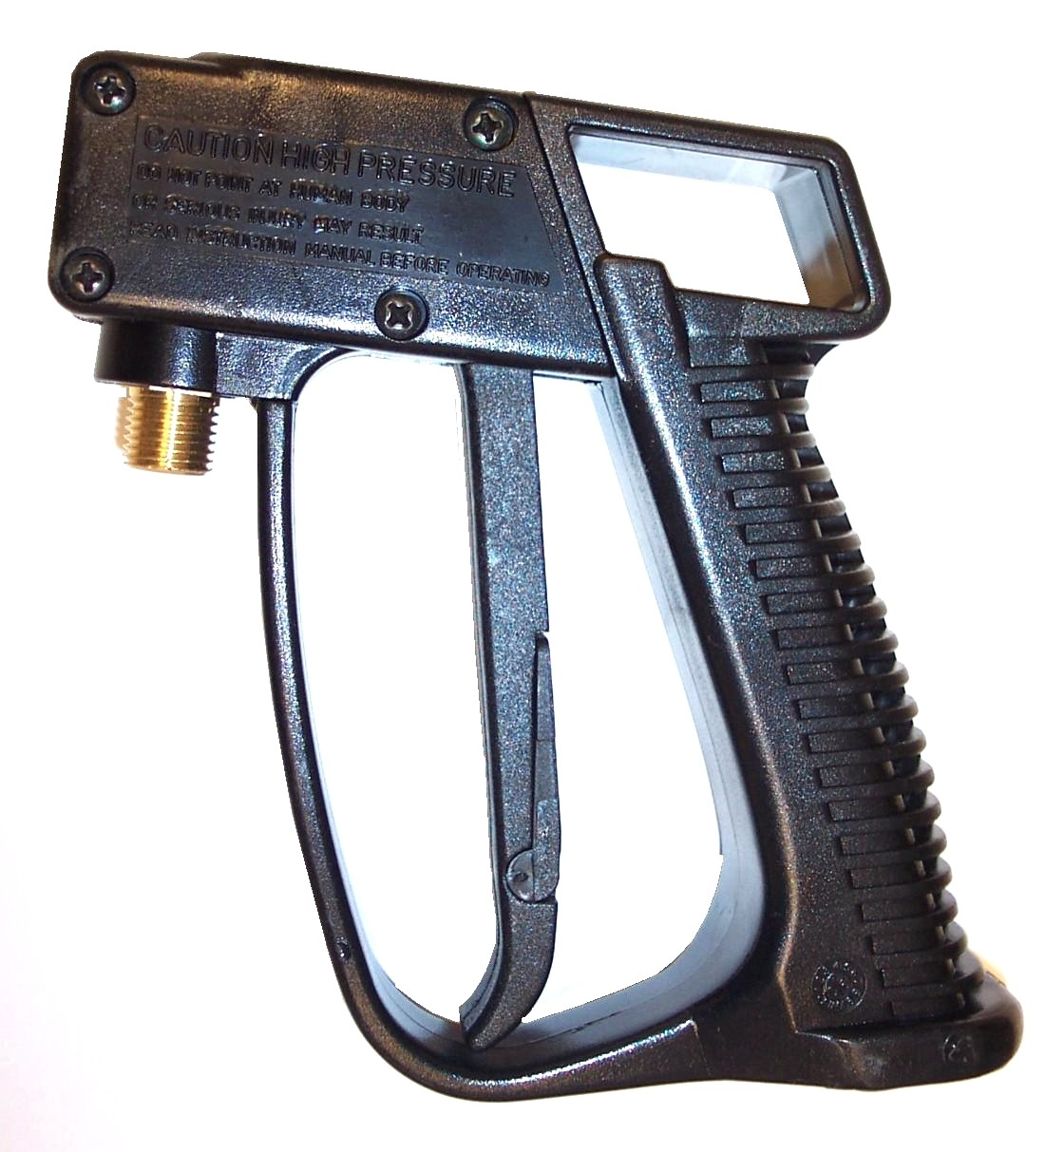
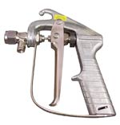

100010

Valve – Plastic Spray Gun
7GPM - 2600PSI
Used on new AS08, AS08P & AS08R
Repair Parts:
Old Valve: NA031
Old Rebuild Kit: NA031A
New Valve: NA033
New Rebuild Kit: NA033A
Plastic Gun Body Only: NA031B

NA1229

Valve – Kingston LP

with lever
Used on AS12 & AS12R
Repair Parts:
Stem Assembly: NA1231
Cap: NA1233
Spring: NA1232
Stem O-ring: NA1230

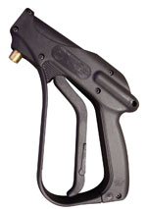
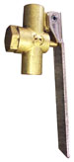

NA0824

Brass Sprayer Extension

18” Curved End

Used with NA0820 & NA0820A

B280

8006 Brass VeeJet – 1/4” FPT
Used AS08 & AS08R with NA0833 Extension

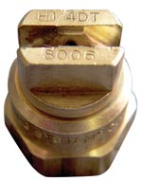

NA1234

Brass Sprayer Extension

12” Curved End
Used with NA1229

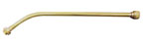

B028

8005 Brass TeeJet

Used with AS08, AS08M & AS08R with NA0824 or AS12 with NA1234 Extension
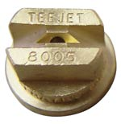

NA0833

Stainless Steel

Sprayer Extension

18” Curved End

Used with NA030

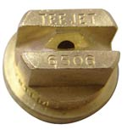

B012

6505 Brass TeeJet
Used with AS08, AS08M & AS08R with NA0824 or AS12 with NA1234 Extension

NA0826

TeeJet Retaining Cap – Brass

Used on AS12 & AS12R. Also used on AS08, AS08M and AS08R with brass NA0824 extension

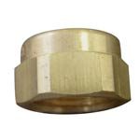

NA1235

Inlet Body – Brass 1/4” FPT

Used on AS12 & AS12R as jet connector on NA1234 extension

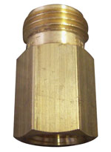

Bridgepoint Parts Catalog

Section XXXIII: Hydro-Force Injection Sprayer Parts Page 2

NA0850A

Injection Valve – HP Revolution

Hydro-Force Sprayer
Used on AS08R

NA0809A

Injection Valve

HP & LP Hydro-Force Sprayer

Used on AS08, AS08M & AS12
Replaces old NA0809

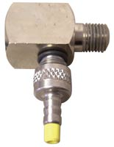
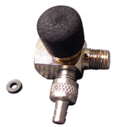

NA0852A

Injection Valve – LP Revolution

Hydro-Force Sprayer
Used on AS12R

NA0841

Repair Kit for Injector Valve

Used for NA0809A, NA0850A & NA0852A on AS08, AS08M & AS12
Kit contains the following parts:
NA0810, NA0811, NA0813, NA0814, NA0837 & NA0838

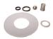

NA0869

Stem Assembly

HP Revolution
Assembly Includes:
Stem: NA0866
O-ring (2): NA0846
Ring Retainer: NA0870
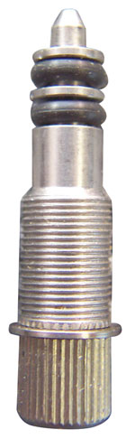

NA0849

Major Repair Kit for AS08 & AS08M Injection Sprayer
Kit contains all parts in Kit NA0841 plus: B208, NA0840, NA0808, NA0807, NA0816, & NA0803

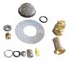

NA0865

Valve Body Only

HP Revolution
Used on NA0850A & NA0852A
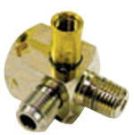

NA0849R

Repair Kit for AS08R

HP Revolution Injection

Sprayer
Kit contains all parts in Kit NA0841 plus: B208, NA0840, NA0808, NA0807, NA0869, & NA0803

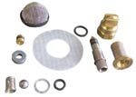

NA0857

Spring – Meter Stem

Old Style Revolution Valve

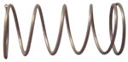

NA0867

Metering Knob

HP Revolution

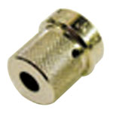

NA0868

Metering Knob

LP Revolution

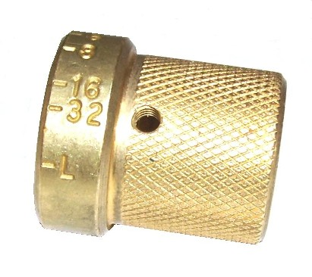

NA0860

Set screw - Metering Knob

Old Style Revolution Valve

NA0872

Thumb Screw 6-32 Knob Lock New Style Revolution Valve

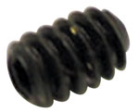
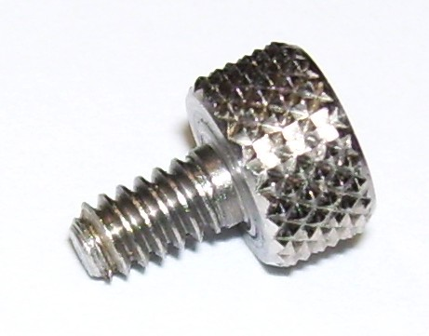

NA0871

Pan screw - Metering Knob

Revolution Valve
10-32 x 1/4” SS PHP
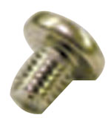

NA0818

Nylon Clamp

Hydro Force Draw Tube

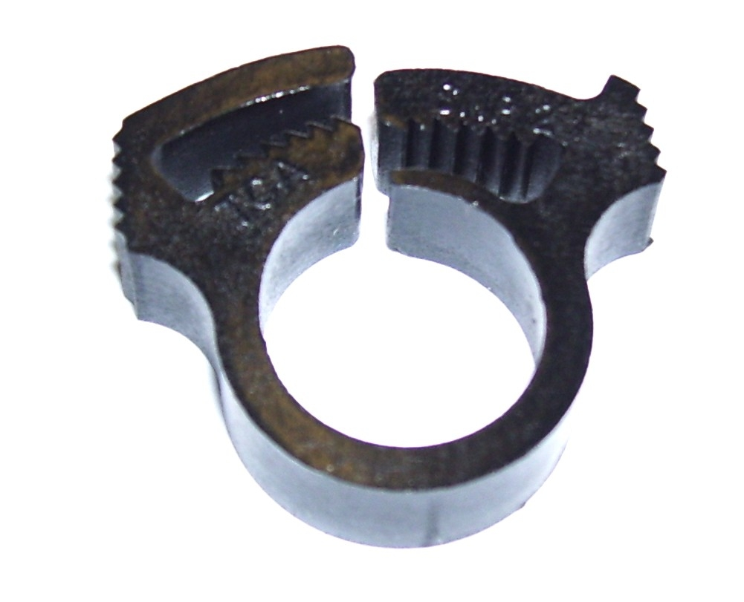

NA0874

O-Ring 3/8” ID x 9/16”OD

Revolution Knob

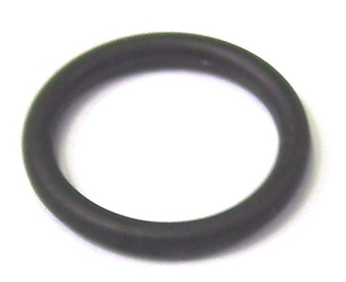
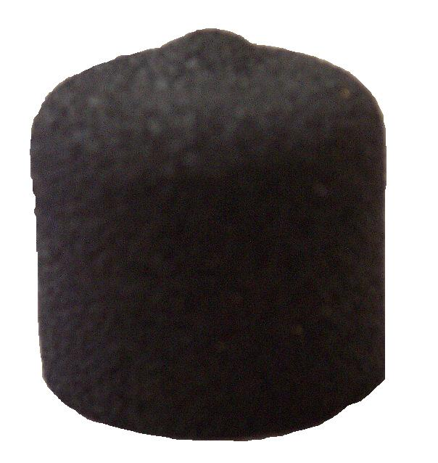

NA0859

Knob Cover – Rubber

Revolution Valve

Bridgepoint Parts Catalog

Section XXXIII: Hydro-Force Injection Sprayer Parts Page 3

NA0828

High Pressure Hose Assembly

Used on AS08, AS08M & AS08R

NA0815

Suction Nut – Check Valve
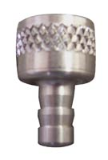
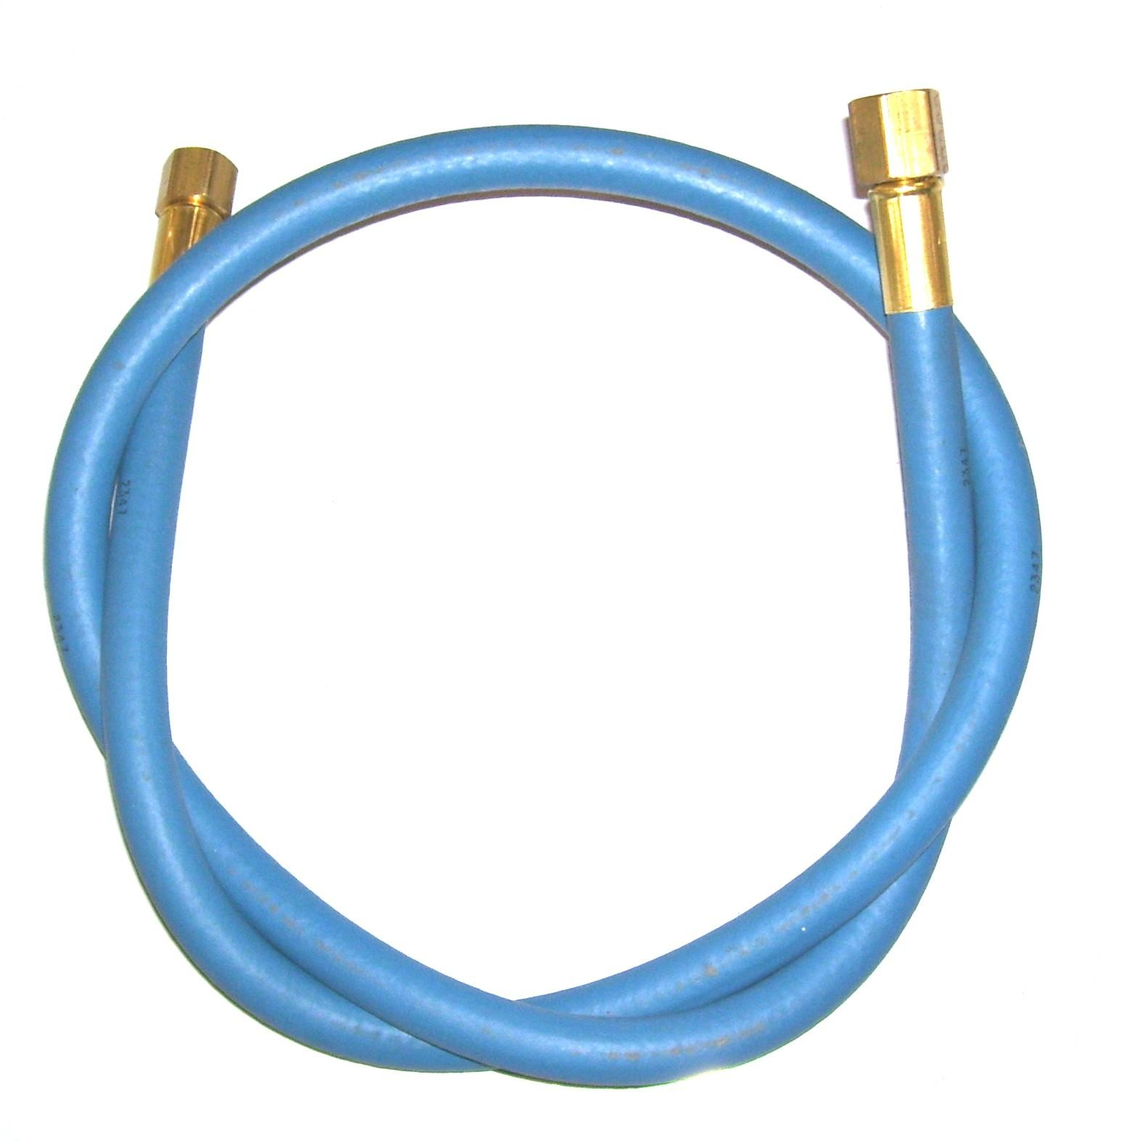

NA0816

Metering Tip – Yellow
Not used on AS08R & AS12R

NA0807

Back-up Washer
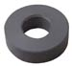
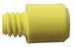

NA0808

Water Nozzle with O-ring
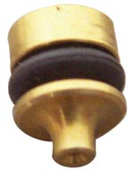

NA0816A

Kit – Metering Tips

High Pressure
Six different colored tips for changing chemical draw rate on AS08 & AS08M sprayers.

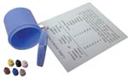

NA0846

O-ring for Water Nozzle and

Revolution Valve Stem
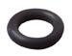

NA0816B

Kit – Metering Tips

Low Pressure
Six different colored tips for changing chemical draw rate on AS12 sprayers.

NA0810

Spring – Check Valve
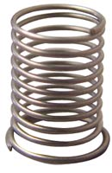
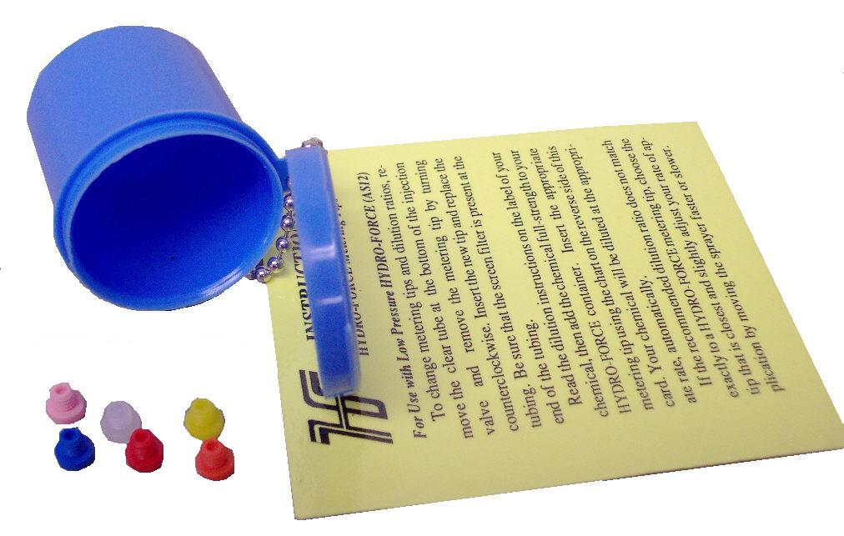

NA0811

Steel Ball – Check Valve


NA0817

Chemical Draw Tube

1/4” ID x 8”

NA0812

Bottle Cap - Vented
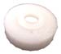

NA0839

Nylon Hose Barb 1/4” Barb x 1/8”MPT

NA0838

Cap Liner

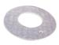
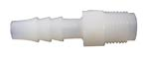

NA0840

Acorn Strainer - 1/8”FPT

NA0837

Viton O-ring

Valve/Cap Seal
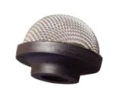

NA0813

Nylon Spacer – Check Valve

AS68L

Cap Hydro Force Side Fill Port
Fits AS68 Bottle
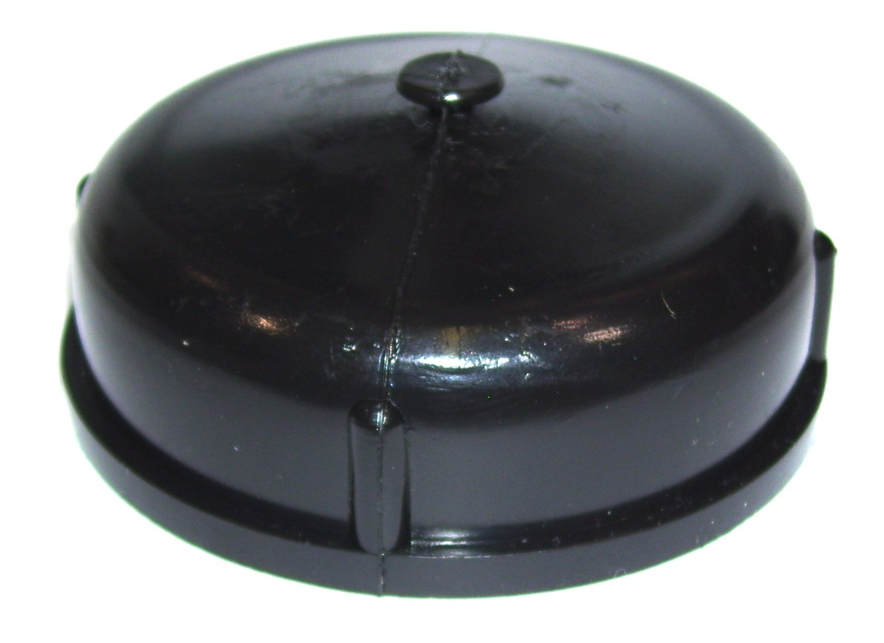
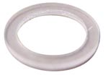

NA0814

Viton O-ring – Check Valve

AS68

Retaining Strap - Side Fill Cap
Use with AS68L on AS68 bottle

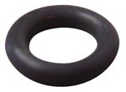
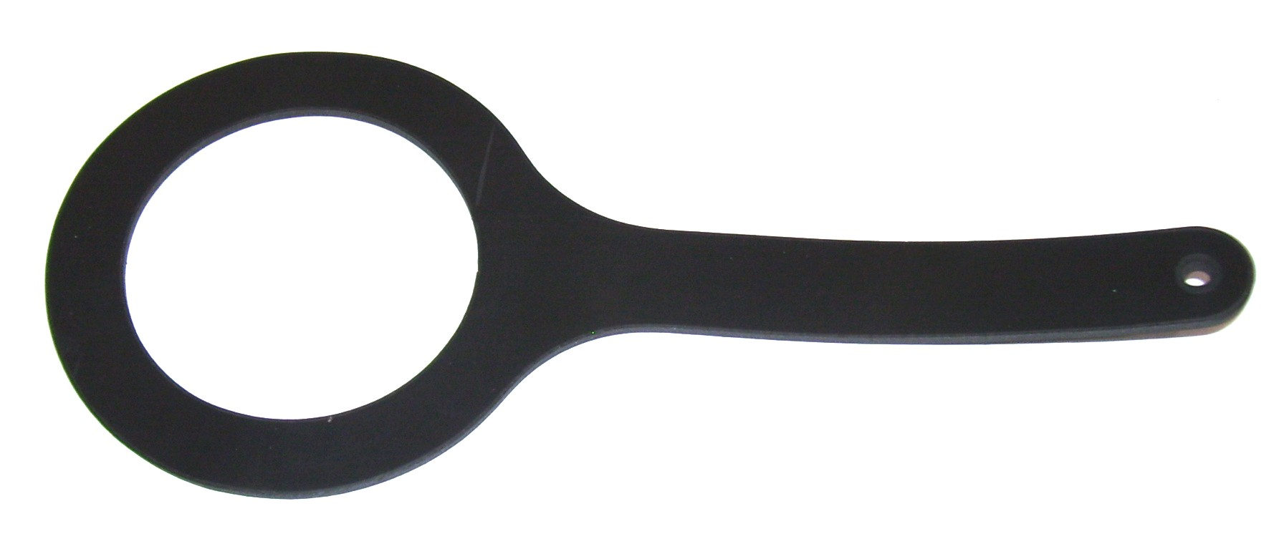

AS68

5QT Side Fill Port - Rotomolded

Sold without caps
Side Cap: AS68L
Retaining Strap: AS69A
Front Cap for storage: XIN56

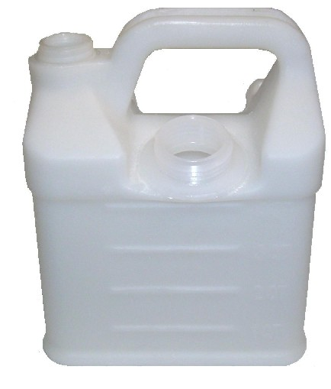

AS68A

5QT Side Fill Port Rotomolded Sold with caps

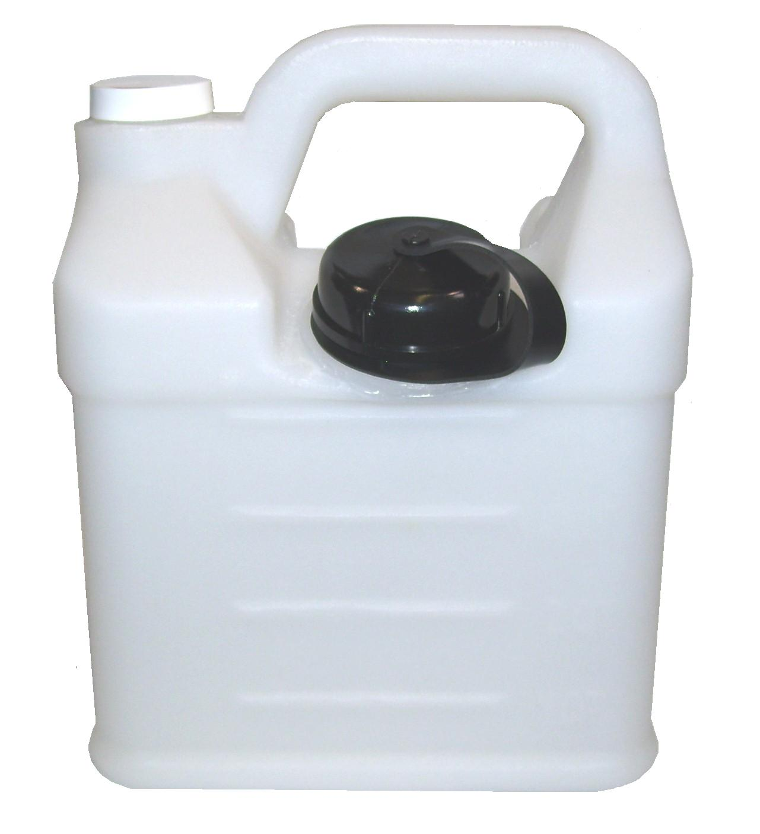

Bridgepoint Parts Catalog

Section XXXIII: Hydro-Force Injection Sprayer Parts Page 4

NA0825

Strainer – 50 mesh

With Check Valve

5psi opening pressure used to limit jet dripping on sprayers using NA0824 extension or NA1235 inlet body with NA1234 extension. Caution: May restrict flow & change chemical draw rate.

NA0806A

Insulated Handle

Used on AS08, AS08M & AS08R
Replaces old style NA0806

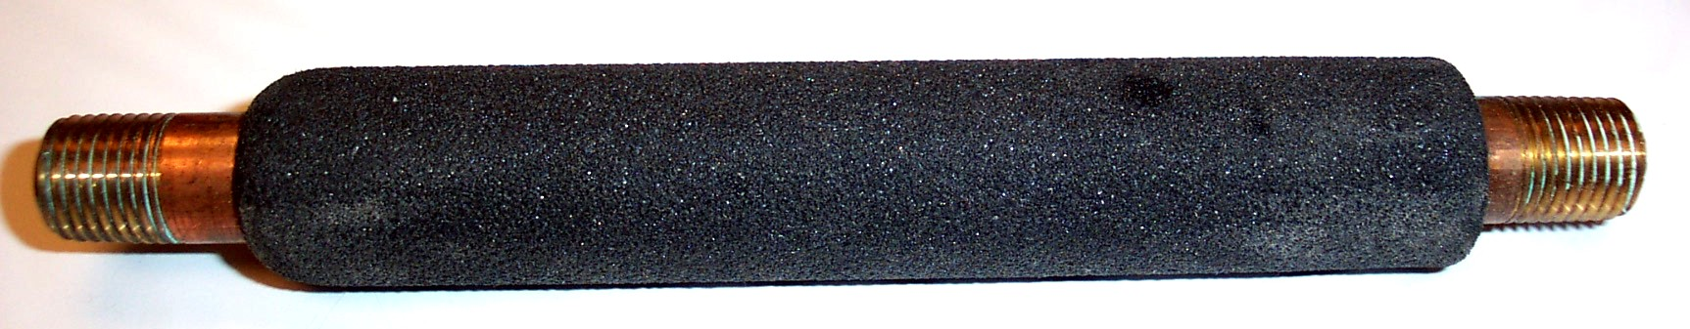
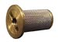

AH102B

1/4” Male Quick Connect

Brass - Hydro-Force Brand

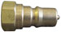

AS30

5- Quart Container with Cap

Old Style – Used on AS08P
Bottle Only: XIN95
Cap Only: XIN56
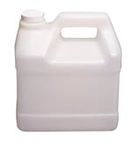

NA0802

Strainer Body
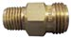

LM93

Hydro-Force Labels – Blank

Use to label 5-QT containers to identify chemical contents.

NA0803

Strainer – 50 mesh

No check valve
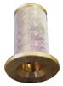

NA0804

Strainer Adapter

NA0819

Velcro Strap with Buckle
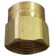
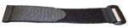

NA0848

Velcro Strap with Loop

AS65

5QT Jug Natural - Rotomolded

With Caps

Hydro Force Sprayer

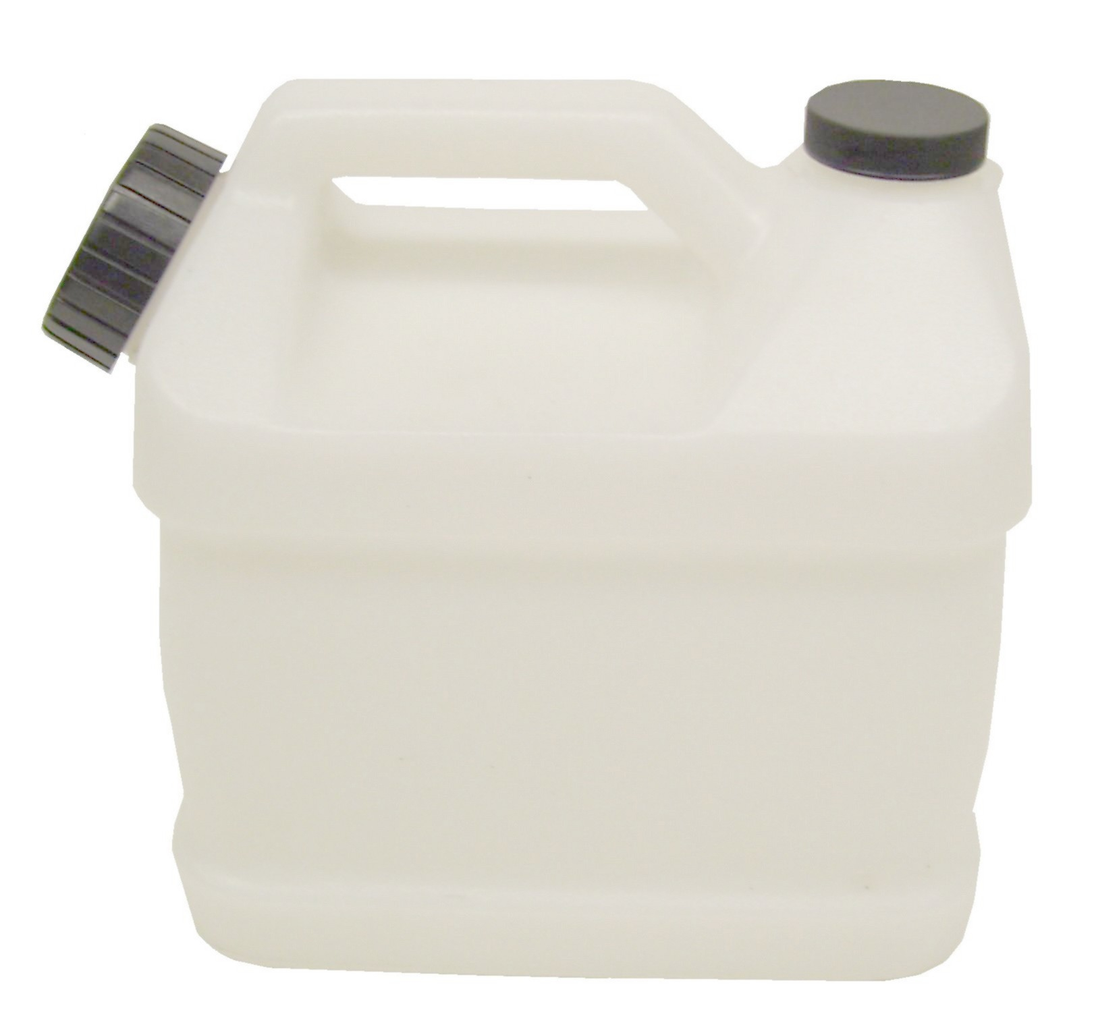

BR335

1/4"Male Quick Connect

Flo-Thru – Brass 1/4” Fpt

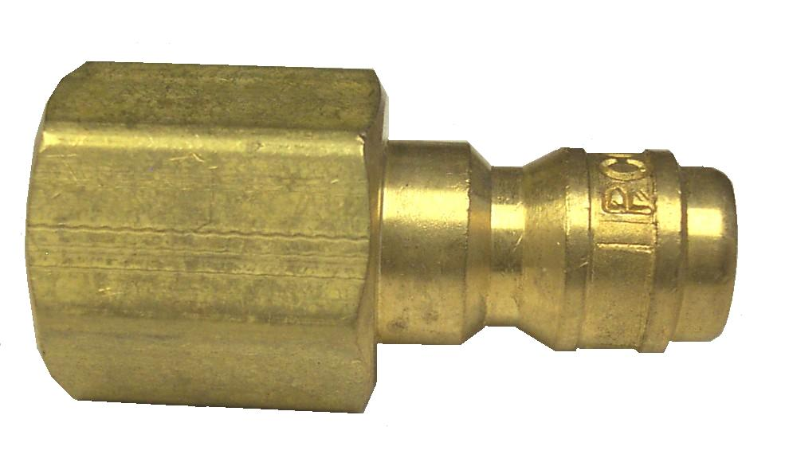

AS66

7QT Jug Natural - Rotomolded

With Caps

Hydro Force Sprayer

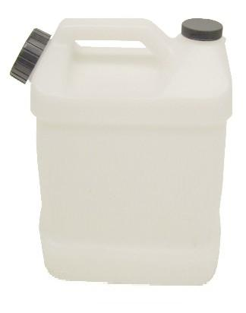

BR337

1/4"Female Quick Connect

Flo-Thru – Brass 1/4” Mpt
Replacement O-Ring: NA0873

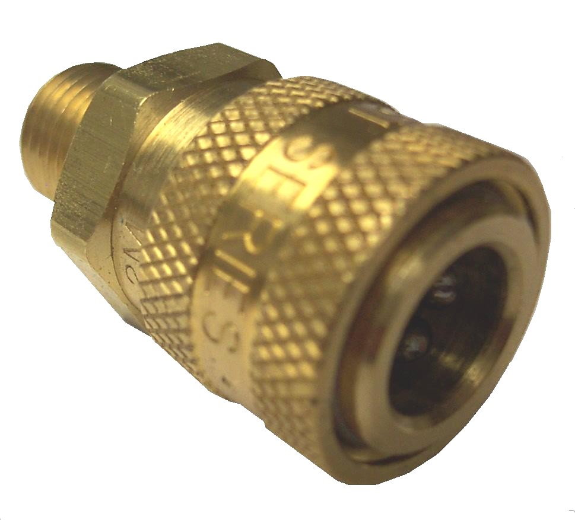

LM901

Label HF Pro Sprayer AS08

LM900

Label HF Revolution Sprayer AS08R

LM902

Label HF PLUS Sprayer AS08P

